NEWS ARCHIVE

June 2021
Summer Camp look-back
17 of our members (well, 16 and a last minute guest member to fill a late spot) are just home from a wonderful weekend at camp (5-7 June).
There were many achievements, new friendships made and bucket lists ticked. The camaraderie and support for each other was just wonderful.
Massive thanks to Rachel Elizabeth Graham for organising for the club and for the fabulous Equiteam Confidence Camps who ran an awesome 3 days for us. Top coaching, wonderful food and just the perfect ingredients to give us a top time. They even ordered the sun to shine!
Thanks to Ian Ryder Photography for coming and taking the official photos, we are so excited to see them.
Lindores Equestrian never disappoints and it was on top form this weekend!
(So sorry for 2 of our campers who had to cancel at last minute, we missed you both.)

May 2021
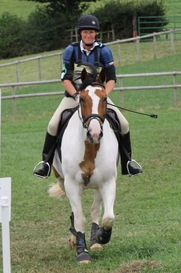
Sandra Lamb
It is with great sadness that we announce that Sandra Lamb has passed away after a short illness. Sandra was almost synonymous with the club, having been a member for well over 20 years, and having been in the committee for a substantial part of that time. She served as Chair twice, and with her quiet, unassuming manner she steered the club through some turbulent times. She was an expert in organising shows and especially the most complicated variety: the Annual Show. Even if she wasn't involved in the organisation, she and her husband Peter would be there to help setting up or clearing away.
She could always be relied on to participate in team events, albeit in dressage, show jumping (in particular style jumping) or eventing. She is most fondly remembered competing her handsome gelding Toad, with whom she made it all the way to the national riding club championships.
Sandra's funeral will be on Wednesday the 19th of May (strictly by invitation only due to Covid). Family flowers only, but donations gladly received for St Andrews Hospice in Airdrie.

